Locally Important Views Within Tavistock Parish

Do you have a favourite iconic view in and around Tavistock?  The Tavistock Neighbourhood Development Plan team are keen to know what views are important to you so that we can protect the most important and relevant of these from future inappropriate development.  Please let us know what views are important to you by filling in this form and sending it to us at: tavistockplan@gmail.com  If you can take a picture of the view to share with us, that would be really useful. Please attach it when you email the steering group your form. | 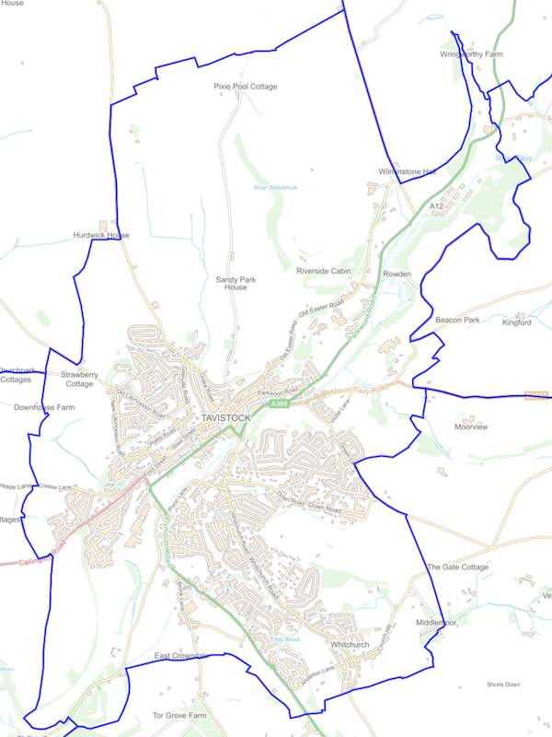  Figure 1. Map of Tavistock Parish

Is the view observable from within the Tavistock Parish boundary? | Yes/No (delete as appropriate)
Is the view publicly accessible (i.e. not a view from private property)? | Yes/No (delete as appropriate)
As best you can, please describe where the view is being observed from:
As best you can, please describe what this view is of:
Please describe why this view is important to you:

We look forward to seeing what iconic views within the parish are important to you.

