Initial Data Review for Tavistock Neighbourhood Development Plan
Community Consultation

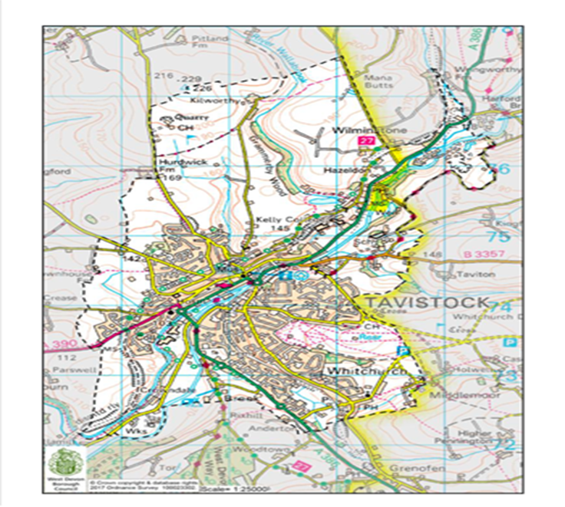

Prepared by
Devon Communities Together
July 2022

Scope: To gather existing information e.g. demographic and socio-economic information. Assess evidence gathered to identify gaps. Source or produce additional evidence if required.

1. Area profile
(Data source Devon County Council Community Profile https://www.devon.gov.uk/communities/your-community/5943-2 )
The Devon Town areas are based on parishes. The parishes that make up the Tavistock area are:
Parishes
Bere Ferrers | Bradstone | Brentor
Buckland Monachorum | Dartmoor Forest | Dunterton
Gulworthy | Horrabridge | Lamerton
Lydford | Mary Tavy | Meavy
Milton Abbot | Peter Tavy | Sampford Spiney
Sheepstor | Sydenham Damerel | Tavistock
Walkhampton | Whitchurch
Not all data is available at parish level so a best fit approach has been used to produce an area definition based on wards and super output areas. The wards in this area are:
Parishes
Bere Ferrers | Buckland Monachorum | Burrator
Lydford | Mary Tavy | Milton Ford
Tamarside | Tavistock North | Tavistock South
Tavistock South West | Walkham
The Lower Super Output Areas in this area are:
Parishes
West Devon 003C | West Devon 004B | West Devon 004C
West Devon 005A | West Devon 005B | West Devon 005C
West Devon 005D | West Devon 005E | West Devon 005F
West Devon 005G | West Devon 006A | West Devon 006B
West Devon 006C | West Devon 006D | West Devon 007A
West Devon 007B | West Devon 007C | West Devon 007D
29,793 population
1,359 crimes reported June 2021 - May 2022
315 people unemployed

2. Data Set: Population profile
(Data source: https://www.devon.gov.uk/communities/your-community/5943-2
The latest population estimate is 29,793. The age breakdown is shown in the table and graph below.
0-4 | 1223 | 5-9 | 1539
10-14 | 1518 | 15-19 | 1634
20-24 | 1033 | 25-29 | 1294
30-34 | 1188 | 35-39 | 1355
40-44 | 1501 | 45-49 | 2086
50-54 | 2477 | 55-59 | 2362
60-64 | 2288 | 65-69 | 2625
70-74 | 2051 | 75-79 | 1433
80-84 | 1064 | 85+ | 1122

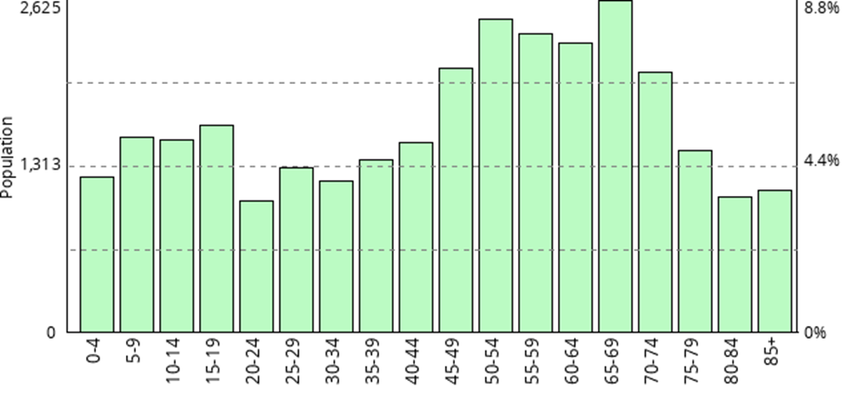

3. Data Set: Household Characteristics profile
(Data source: https://www.devon.gov.uk/communities/your-community/5943-2
Information about the people that live in the area is taken from Experian's Mosaic data. Mosaic is based on the assumption that people living in an area are likely to be similar; however, it does not provide definitive description of each person.
The Mosaic data are broken down into a number of groups, each one describing a section of the population.
 | Area |  | Devon
Household type | Number of households | Percent of households | Percent of households
A: Residents of isolated rural communities | 3389 | 25.0 | 19.6
B: Residents of small and mid-sized towns with strong local roots | 2969 | 21.9 | 17.9
C: Wealthy people living in the most sought after neighbourhoods | 206 | 1.5 | 1.1
D: Successful professionals living in suburban or semi-rural homes | 2003 | 14.8 | 8.2
E: Middle income families living in moderate suburban semis | 431 | 3.2 | 5.2
F: Couples with young children in comfortable modern housing | 311 | 2.3 | 2.6
G: Young, well-educated city dwellers | 105 | 0.8 | 4.8
H: Couples and young singles in small modern starter homes | 419 | 3.1 | 3.4
I: Lower income workers in urban terraces in often diverse areas | 127 | 0.9 | 2.6
J: Owner occupiers in older-style housing in ex-industrial areas | 915 | 6.8 | 7.4
K: Residents with sufficient incomes in right-to-buy social houses | 879 | 6.5 | 6.9
L: Active elderly people living in pleasant retirement locations | 1086 | 8.0 | 12.4
M: Elderly people reliant on state support | 684 | 5.0 | 5.3
N: Young people renting flats in high density social housing | 12 | 0.1 | 1.1

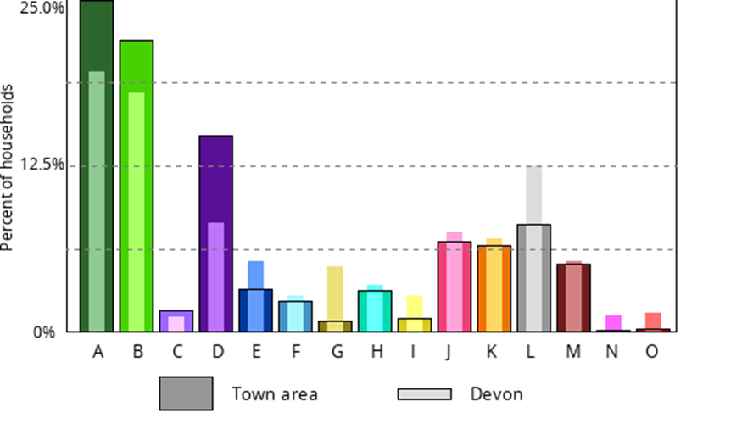

4. Data Set: Housing profile
Data source: National Housing Federation Home Truths The housing crisis in
the South West (West Devon Borough Council October 2021)

 | West Devon | South West | England
South West England Average (mean) house prices in 2019/20 | £284,017 | £295,738 | £309,678
Mean annual earnings in  2019/20 | £27,123 | £26,707 | £30,248
Ratio of house prices to  incomes in 2019/20 | 11 | 11 | 10
Income required for 80% mortgage  in 2019/20 | £64,918 | £67,597 | £70,784
Mean monthly private  sector rents in 2019/20 | £687 | £818 | £843
Unemployment rate in 2019/20 | 2.6% | 3.2% | 3.9%
Housing Benefit claimants - total in  employment (and not Passported)  % | 16.4% | 14.6% | 17.3%
Long term empty homes in 2020 | 107 | 24,530 | 268,385
Second homes in 2020 | 559 | 51,125 | 262,953
Total housing association affordable  homes in 2018/19 | 2,610 | 261,214 | 2,753,583
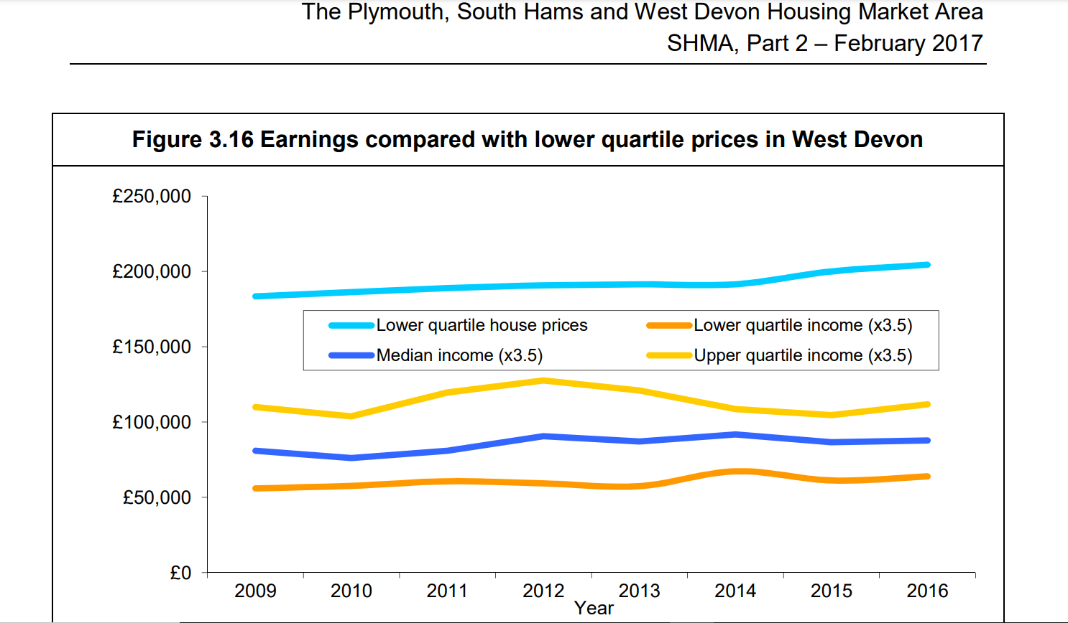

Potential annual demand for shared ownership with 50% equity share West Devon
- One bedroom - 9
- Two bedrooms - 15
- Three bedrooms - 9
- Four bedrooms - 4
- Total - 37

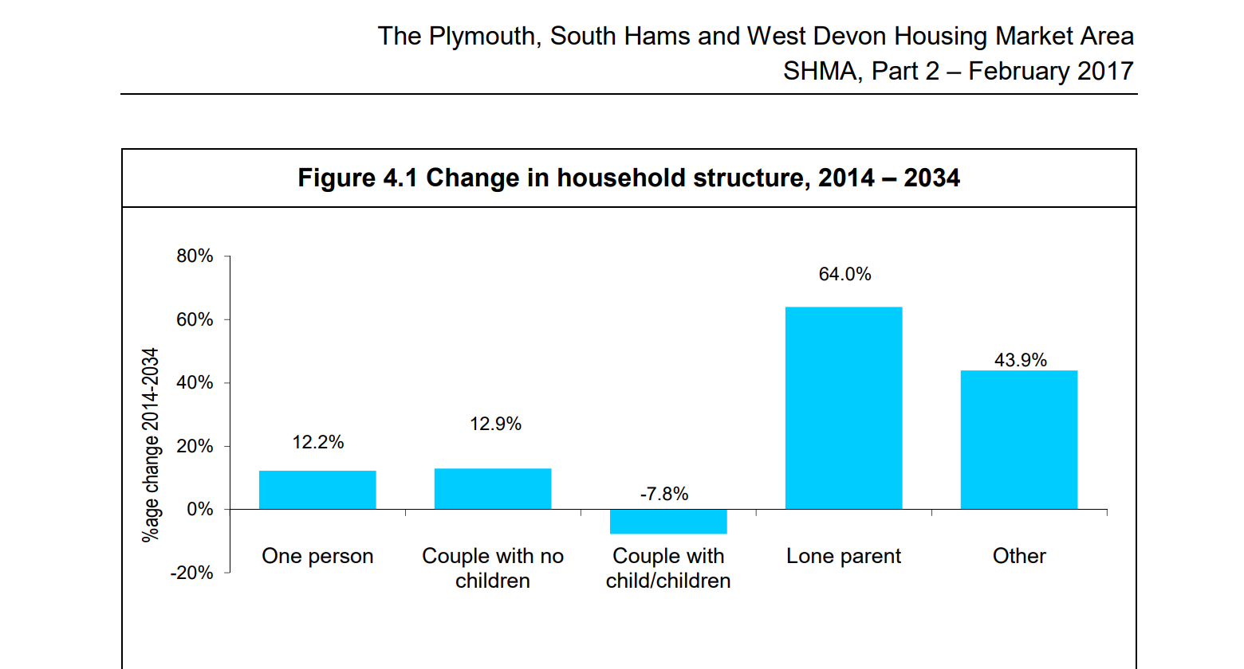

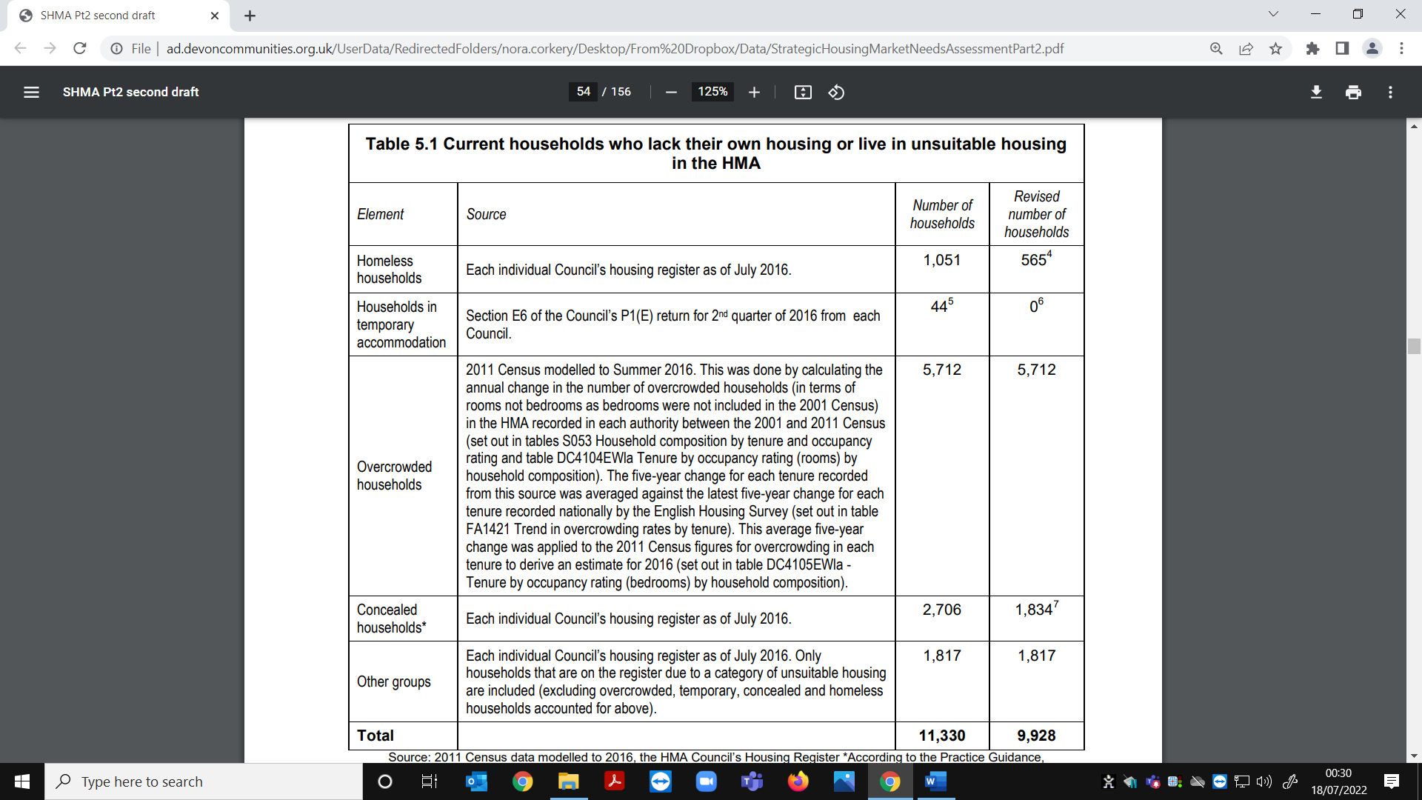
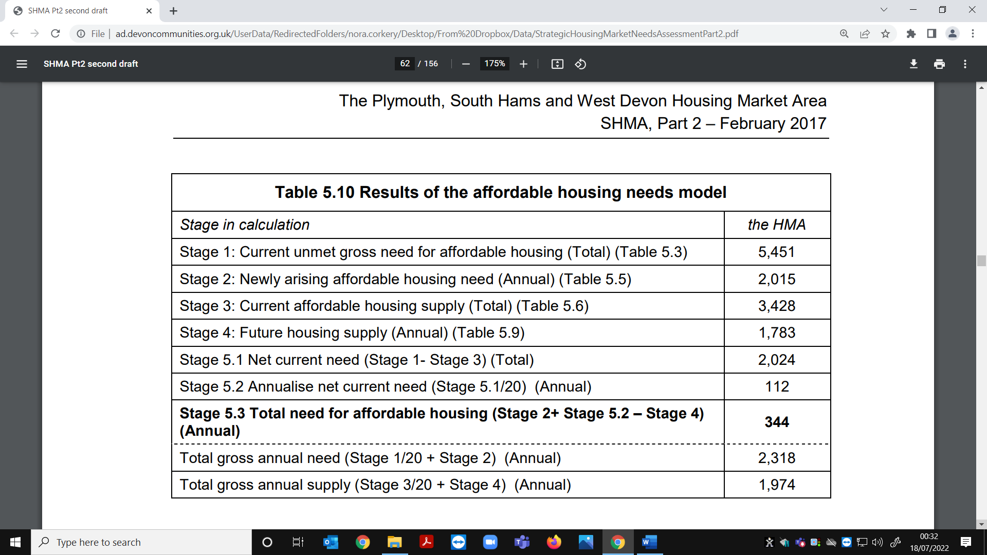

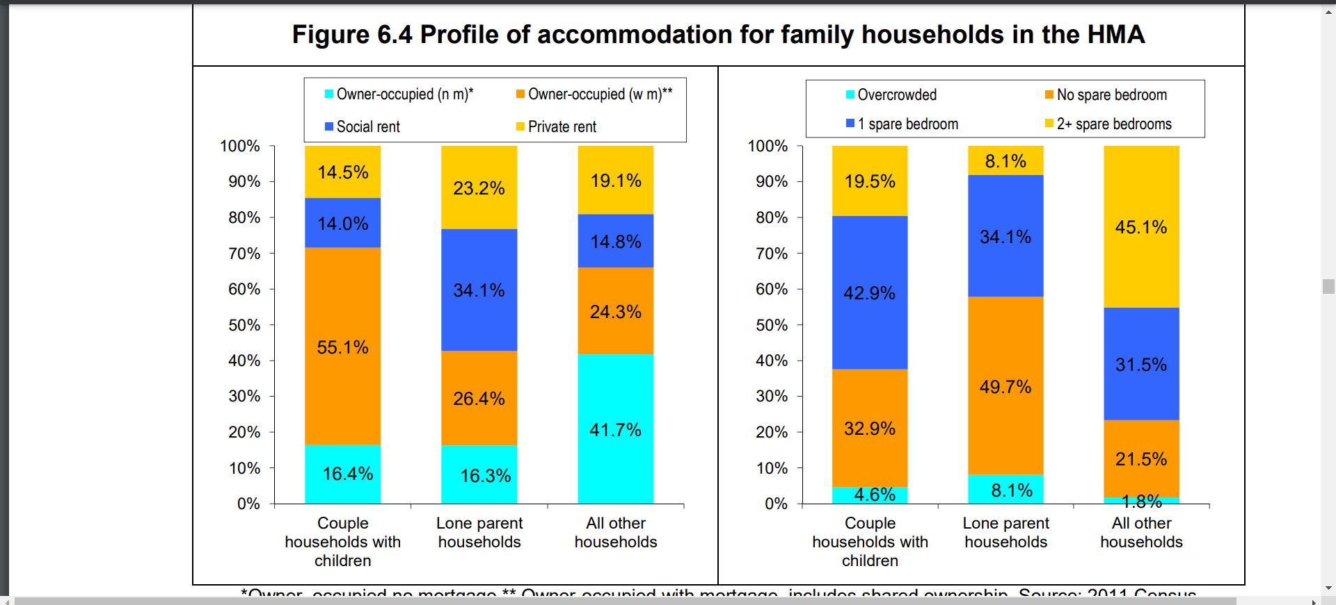
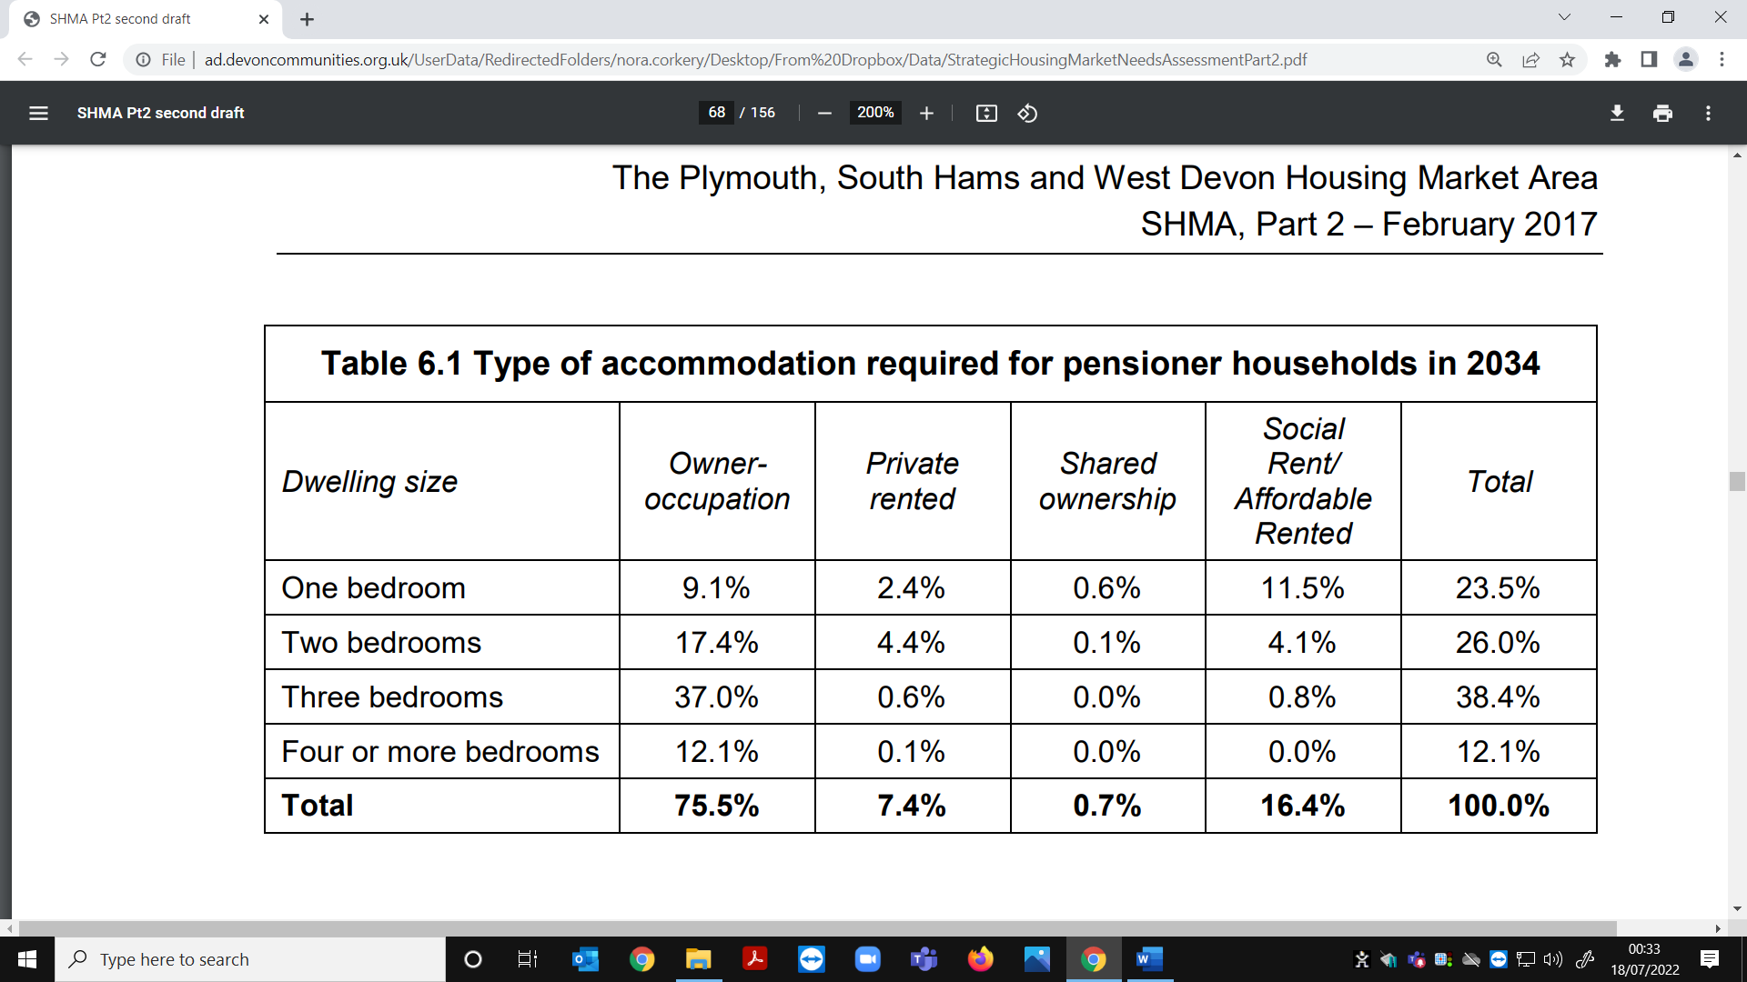

The total annual affordable housing need in West Devon of 57 households per year represents 24.0% of the annual projected household growth in the Borough between 2014 and 2034 (238 households per year as identified within the full OAN calculations). This proportion of new housing as affordable appears achievable to deliver in West Devon.

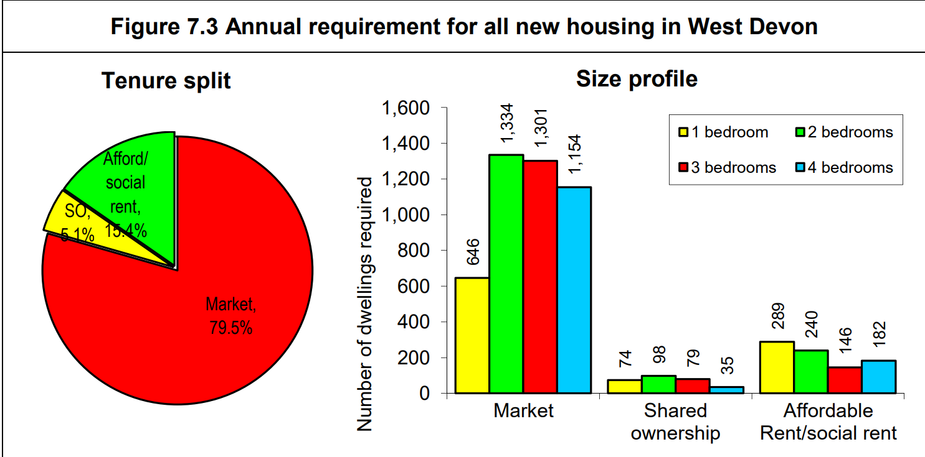

5. Data Set: Extra Care Housing Need
(Data source: Devon County Council Refresh of the Commissioning Strategy
for Extra Care Housing (2009) published August 2015)

On a county wide level, currently 11% of the population is aged 75 or over,
although there are distinct variations from district to district. For example,
the percentage of older people in East Devon at 15% is significantly higher
than the proportion of older people living in Exeter, at only 8%

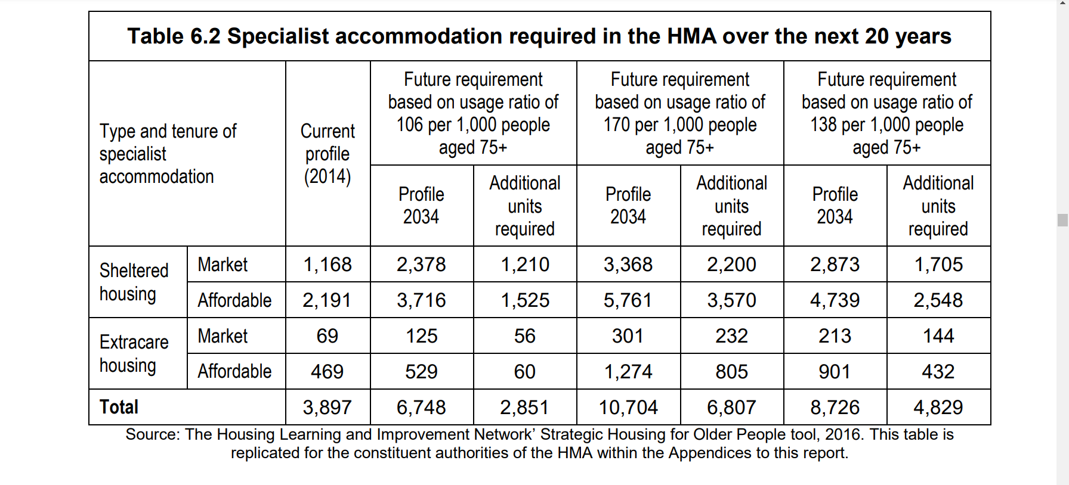

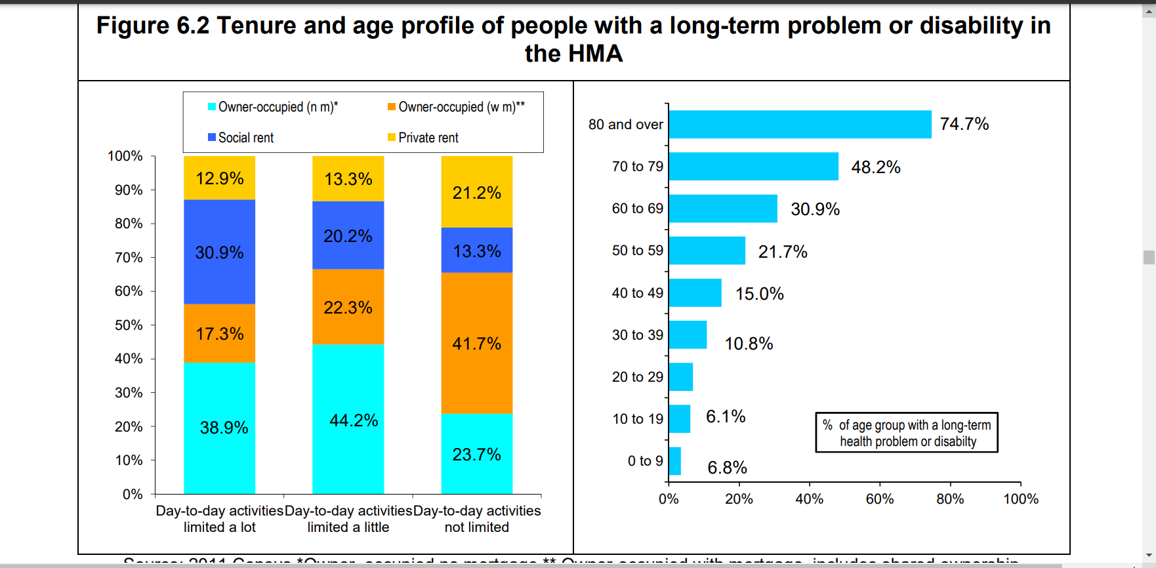

Within the HMA the proportion of the population with a long-term health problem or disability is, 20.4% in Plymouth, 19.2% in South Hams and 20.1% in West Devon. Further analysis shows some 46.8% of all residents with a long-term health problem or disability in the HMA had a condition that limited day-to-day activities a lot, with 53.2% having a condition that limited activities a little.

West Devon total population (2011) - 53,553 (Devon 746,399), population aged 75 or over 5,711- 11 % of the population aged 75+ (Devon 82,006 11 % of the population aged 75+).

Projections are that by 2033 West Devon total population will be – 58,713 19 % of the population aged 75+. (Devon 865,575), population aged 75 or over will be 11,230 (Devon 147,021 17% of the population will be aged 75+.)

The number of West Devon residents over the age of 75 living with a limiting long term illness is 5,215, 91% (Devon - 76,027, 93%).County wide, 29% of people over the age of 65 live alone (2011 census), West Devon – 27%.

Tavistock Extra Care Housing Need Projection to 2033

 | Town area population (Census  2011) | Town Area as % | No of ECH units required | Current town area ECH unit  requirement
 | 30,054 | 53% of West Devon need | 92 | 48
2033 Projections | 30,828 | 53% of West Devon need | 179 | 94

6. Data Set: Deprivation profile
(Data source: https://www.devon.gov.uk/communities/your-community/5943-2 https://www.gov.uk/government/statistics/english-indices-of-deprivation-2015
The principal source of deprivation data in England are the Indices of Deprivation. This is a series of datasets with the latest edition having been released in 2010.The indices are broken down into 7 domains - income, employment, health and disability, education & training, crime, the living environment and barriers to housing & services. These domains are then combined to produce an overall measure of multiple deprivation.
There are over 32,000 small areas (known as Lower Super Output Areas) in England. These can be thought of as neighbourhoods. There are 18 LSOAs in the Tavistock area and their ranks are shown in the table below.
Lower Layer Super Output Areas (LSOAs) have an average population of 1500 people or 650 households. Indices of Multiple Deprivation (IMD) Rank (out of 32,482 - 1 is most deprived).
LSOAs IMD Ranking

West Devon 003C – 9.057 | West Devon 004B - 14,982 | West Devon 004C - 14,479
West Devon 005A – 14.910 | West Devon 005B - 25,264 | West Devon 005C - 12,797
West Devon 005D - 19,224 | West Devon 005E - 32,064 | West Devon 005F - 11,891
West Devon 005G - 18,484 | West Devon 006A - 22,844 | West Devon 006B - 15,521
West Devon 006C - 22,966 | West Devon 006D - 14,904 | West Devon 007A - 18,445
West Devon 007B - 9,924 | West Devon 007C - 19,123 | West Devon 007D - 27,591

7. Data Set: DWP Benefits Profile
(Data source https://www.devon.gov.uk/communities/your-community/5943-2 )
The Department for Work and Pensions provides details of the number of people claiming various benefits. The table below shows the number of people claiming benefits in November 2018.
 | Tavistock area |  | Devon
Benefit | Claimants | Percent | Percent
All people claiming Disability Living Allowance (DLA) | 730 | 2.4 | 2.6
People aged 16 and over claiming Incapacity Benefit/Severe Disablement Allowance | 20 | 0.1 | 0.1.
People aged 16 to retirement age claiming Income Support (IS) | 105 | 0.6 | 0.9
People aged 16 to retirement age claiming Job Seekers Allowance (JSA) | 40 | 0.2 | 0.4
People of retirement age* claiming Pension Credit (PC) | 800 | 8.9 | 9.9
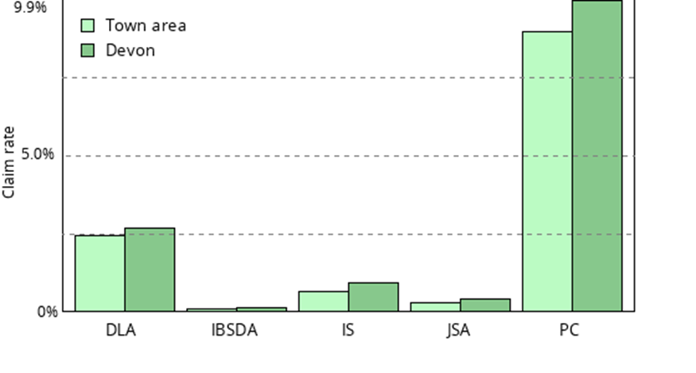

8. Working & Child Tax Credits in West Devon
(Data source: https://webarchive.nationalarchives.gov.uk/ukgwa/20181001162018/https://www.gov.uk/government/statistics/child-and-working-tax-credits-statistics-provisional-awards-geographical-analyses )

2018 data set
Out of Work with children | Working/ Child Tax Credit recipients with children | Child Tax Credit only recipients with children | Working Tax Credit recipients (no children) | Total Number of families receiving Tax Credits
500 families | 1200 families | 700 families | 500 | 3000
900 children | 2200 children | 1600 children

9. Data Set: Employment profile
(Data source: https://www.devon.gov.uk/communities/your-community/5943-2 )

There are currently 315 people unemployed and claiming benefits in the Tavistock area.
This equates to 1.9% of the working age population. Across Devon as a whole the rate is 2.2%.
The percentage of the workforce that work in various industries is shown below.
Industry | Tavistock area | Devon
1: Agriculture, forestry and fishing | 0.7% | 0.3%
2: Mining, quarrying & utilities | 1.2% | 1.8%
3: Manufacturing | 4% | 8.9%
4: Construction | 5.5% | 5.5%
5: Wholesale and retail trade; repair of motor vehicles | 18.3% | 19.3%
6: Transportation and storage | 2.2% | 3.8%
7: Accommodation and food services | 14.4% | 10.1%
8: Information and communication | 2.2% | 2.8%
9: Finance and insurance | 1.8% | 1.8%
10: Real estate | 2.3% | 1.6%
11: Professional, scientific and technical | 4% | 5.3%
12: Administrative and support services | 1.9% | 5%
13: Public administration and defence | 6.5% | 5.3%
14: Education | 14.8% | 9.5%
15: Health and social work | 14.9% | 14.5%
16: Arts, entertainment and recreation | 2.4% | 2.3%

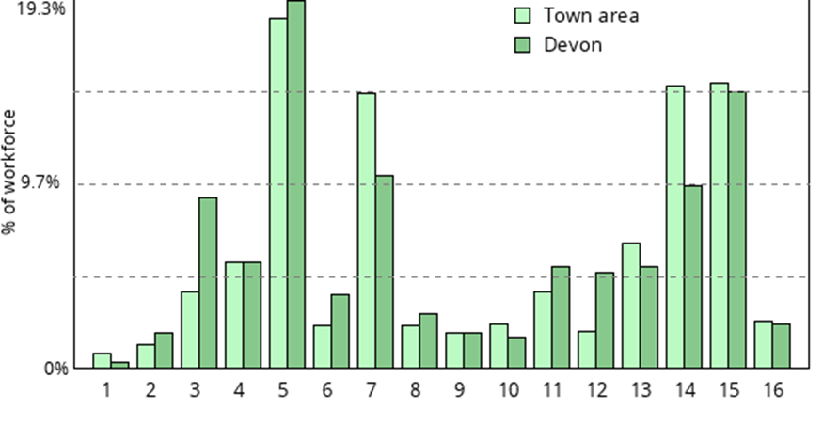

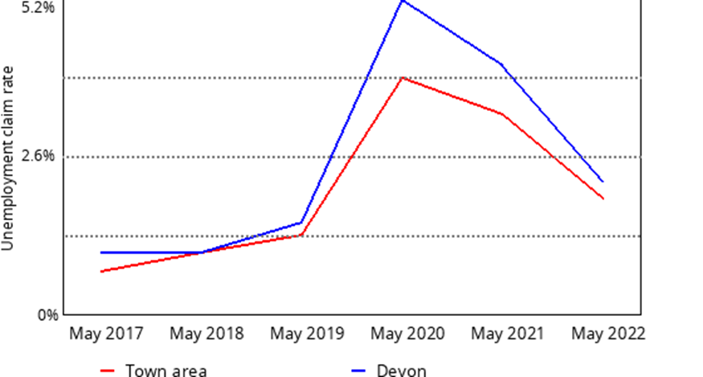

10. Data Set: Crime Profile
(Data source: https://www.devon.gov.uk/communities/your-community/5943-2 Home Office. © Crown copyright.
Published under the Open Government Licence.
Crime categories are sometimes changed. Details of any changes can be found on the data.police.uk website.

In total there were 1,359 crimes recorded in the Tavistock area between June 2021 and May 2022.
Crime category | Jun 21 | Jul 21 | Aug 21 | Sep 21 | Oct 21 | Nov 21 | Dec 21 | Jan 22 | Feb 22 | Mar 22 | Apr 22 | May 22
Anti social behaviour | 34 | 36 | 21 | 24 | 21 | 12 | 51 | 19 | 11 | 16 | 28 | 31
Burglary | 2 | 4 | 5 | 0 | 2 | 5 | 1 | 3 | 2 | 3 | 2 | 5
Criminal damage arson | 22 | 16 | 19 | 7 | 18 | 14 | 16 | 5 | 8 | 12 | 13 | 17
Drugs | 2 | 2 | 0 | 2 | 2 | 0 | 6 | 5 | 2 | 5 | 4 | 3
Other theft | 3 | 9 | 7 | 5 | 6 | 5 | 6 | 10 | 7 | 14 | 2 | 12
Possession of weapons | 0 | 1 | 0 | 0 | 0 | 0 | 1 | 0 | 1 | 2 | 1 | 1
Public order | 5 | 3 | 4 | 10 | 4 | 4 | 3 | 3 | 3 | 9 | 7 | 13
Shoplifting | 0 | 2 | 1 | 1 | 1 | 0 | 4 | 1 | 3 | 4 | 1 | 4
Vehicle crime | 8 | 2 | 4 | 4 | 2 | 1 | 5 | 1 | 1 | 2 | 9 | 3
Violent crime | 34 | 42 | 28 | 54 | 40 | 48 | 60 | 42 | 32 | 43 | 47 | 50
Other crime | 9 | 7 | 8 | 2 | 3 | 7 | 4 | 3 | 11 | 3 | 6 | 9
Bicycle theft | 0 | 0 | 0 | 1 | 0 | 0 | 0 | 0 | 0 | 0 | 1 | 0
Theft from the person | 0 | 1 | 0 | 0 | 0 | 0 | 1 | 0 | 0 | 0 | 0 | 0
Total | 119 | 125 | 97 | 110 | 99 | 96 | 158 | 92 | 81 | 113 | 121 | 148

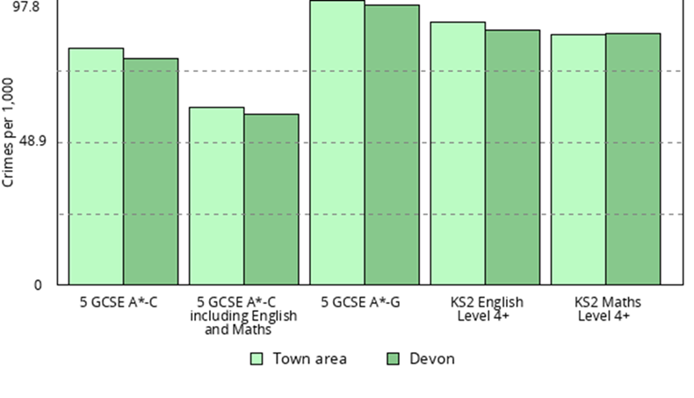
11. Data Set: Education profile
(Data source: https://www.devon.gov.uk/communities/your-community/5943-2 )
The percentage of pupils achieving the expected level in English and Maths at Key Stage 2 (age 11) and at GCSE are shown in the table and graph below.
Percent of students achieving | Tavistock area | Devon
At least Key Stage 2 Level 4 in English | 90.2 | 87.6
At least Key Stage 2 Level 4 in Maths | 85.8 | 86.1
5 or more GCSEs at grades A* to C | 81.3 | 77.8
5 or more GCSEs at grades A* to C including English and Maths | 60.9 | 58.6
5 or more GCSEs at grades A* to G | 97.8 | 96.0

12. Data Set: Health & Wellbeing profile
(Data source: https://www.devon.gov.uk/communities/your-community/5943-2 https://www.devonhealthandwellbeing.org.uk/jsna/jsna-headline-tool/ )

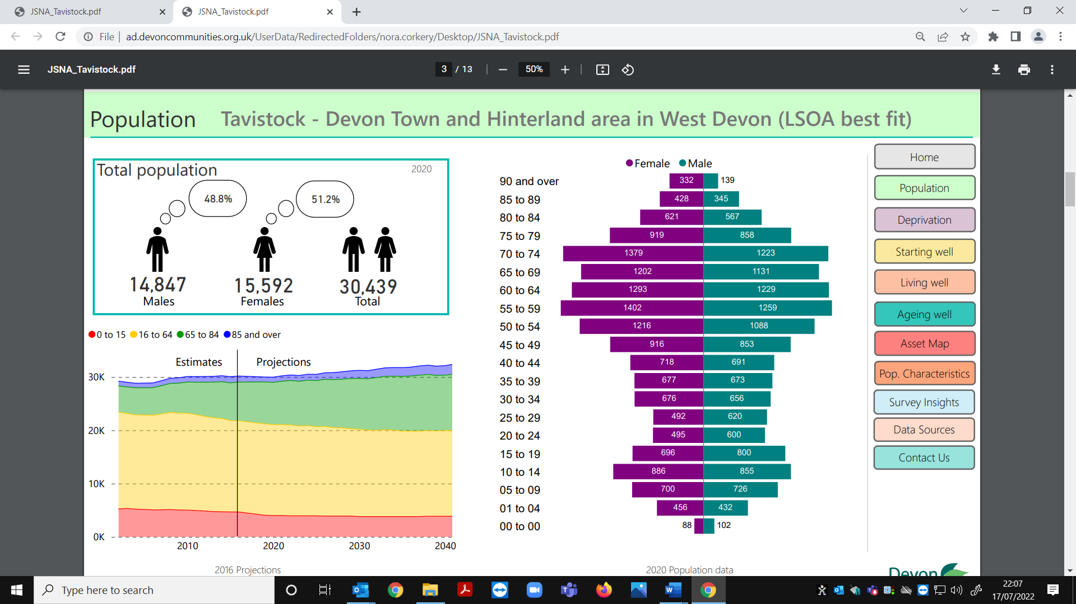

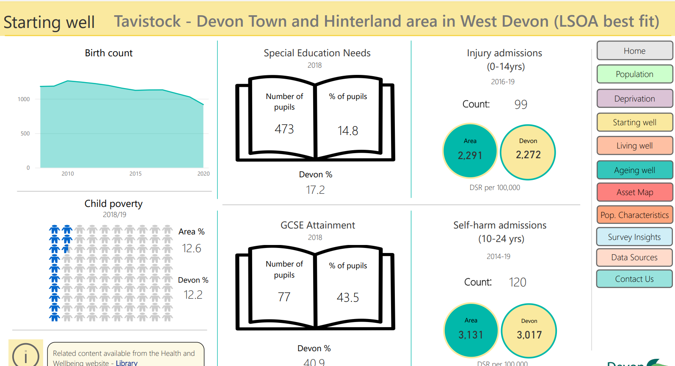

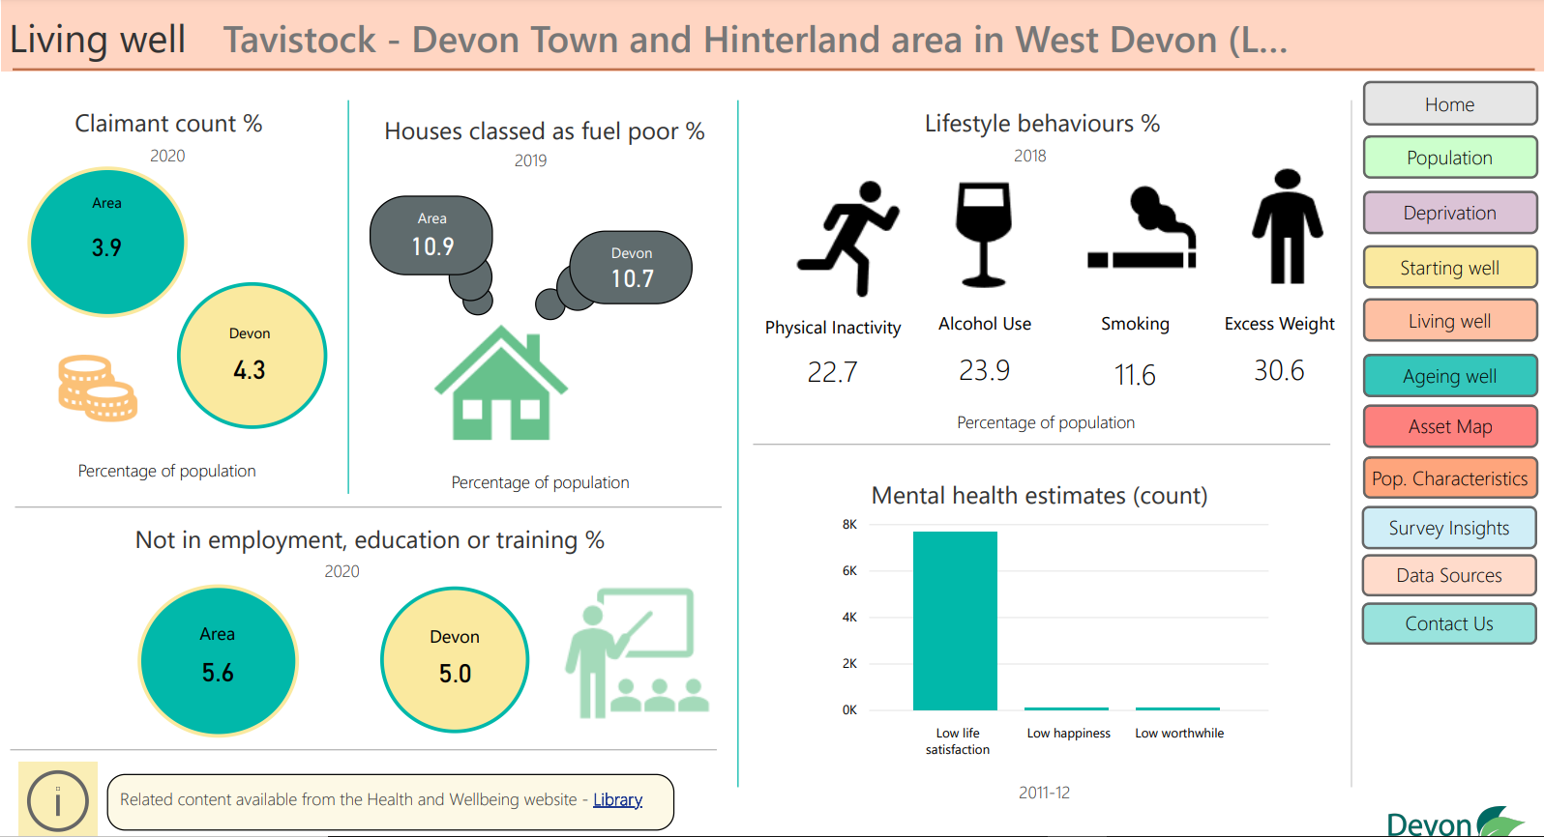

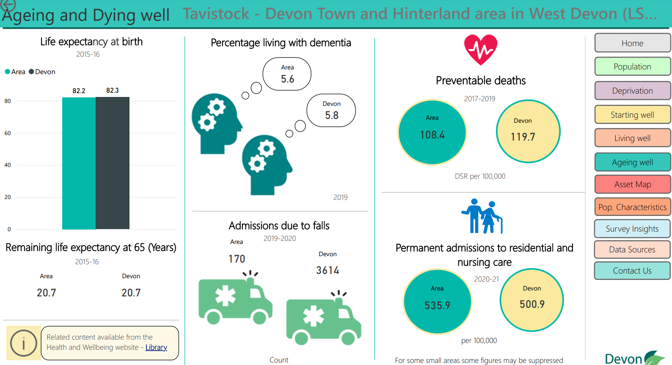

13. Data Set: Tavistock Community Wellbeing Survey Insight 2019
Summary of survey responses received

Wellbeing Area | No. Responses
Good social contact | 63
Feel Safe | 83
Access to green spaces | 82
Volunteer in the local community | 62
Good travel access | 41
Access to resources and activities | 108
Feel they can look after themselves or have support | 168.3

14. Census 2021 Data Set: First Results - Population
(Data Source: https://www.ons.gov.uk/peoplepopulationandcommunity/populationandmigration/populationestimates/bulletins/populationandhouseholdestimatesenglandandwales/census2021 )
The first data from the 2021 Census has been released by the Office for National Statistics. They show an increasing and ageing population both nationally and in Devon. The detailed data sets may be out in the Autumn but it’s not clear how granular this could be and it may even be Spring/Summer 2023 in terms of final granularity.
Headline Figures
- South West population increase of 5,700,000 7.8%.

- The Census puts the population of Devon at 811,600. This is up from 746,400 ten years ago – an increase of 65,200 or 8.7%. The largest increase was East Devon which saw an increase of 18,400 people – up 13.9% from 2011 to 150,800. West Devon saw the smallest increase with 3,600 extra people taking the total to 57,100 – an increase of 6.7%.

- West Devon population 2011 - 53,500 and 2021- 57,100 an increase of 3,600 6.7%

- Similar to the national picture there has been an increase in the number of older people living in the county. Since 2011, there are now 40,800 more people aged 65 and over in Devon taking the total number to 209,400 or 25.8% of the total population. In 2011 the figures were 168,600 (21,100 more) & 22.6%.

- The age structure differs significantly between districts with 49% in Exeter aged under 35 compared to just 32% in West Devon. However, just 17% of people in Exeter are aged 65 and over compared to 30% in East Devon.

- There has also been a corresponding increase in the number of households in the county. The largest increases were East Devon and Teignbridge, which saw an increases of 7,700 (13.0%) and 5,800 (10.7%) respectively.

- West Devon number of households 2011 - 22,700 and 2021 - 24,800 an increase of 2,100 9.3%.

- In Devon there are, on average, 2.3 people per household. This compares to 2.41 people in England as a whole. If the average household size in Devon matched the national figure there would be 12,200 fewer households. This relatively small household size may be due to the age structure of the population with more older people living alone, although the full
picture won’t be known until more data are released later in the year.

- Except in Exeter, East Devon & South Hams, the household size has decreased across all Devon districts between 2011 and 2021. West Devon average household size 2011 - 2.36 and 2021 - 2.30.

- The most densely populated district is Exeter with 2,783 people per square kilometre. By comparison, the least densely populated district is West Devon with 49 people per square kilometre.

